**CS5551-Advanced Software Engineering**

**Group 6 – Challenge-2 Report**

**By**

* **Kommineni, Siva Krishna (ID-20)**
* **Thallapalli, Ravisha (ID-37)**
* **Bandaru, Sarath Chandra (ID-5)**
* **Yempalla, Suresh Reddy (ID-49)**

**Activity Diagram:-**

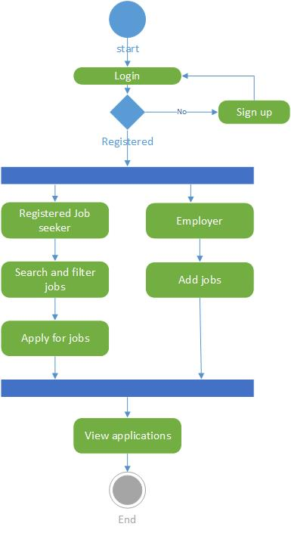

**System Architecture:-**



**Software Specifications:-**

**Tools:** Android Development Kit, Microsoft Visual Studio 2010

**Operating System:** Android, Windows

**Development Operating System**: Windows 8

**Programming Languages:** Java 7.0, C#, ASP.NET

**Databases:** SQL 2008, SQLite

**Data Sources:-**

1. <http://www.linkup.com/developers/>

2. <http://www.programmableweb.com/category/jobs/apis?category=20080>

3. <http://www.labor.ny.gov/jobs/regional.shtm>

4.[https://data.ny.gov/browse?Dataset- Information_Agency=Labor%2C+Department+of&utf8=%E2%9C%93](https://data.ny.gov/browse?Dataset-%20%20Information_Agency=Labor%2C+Department+of&utf8=%E2%9C%93)

**Class Diagram:-**

Various classes are as shown below.

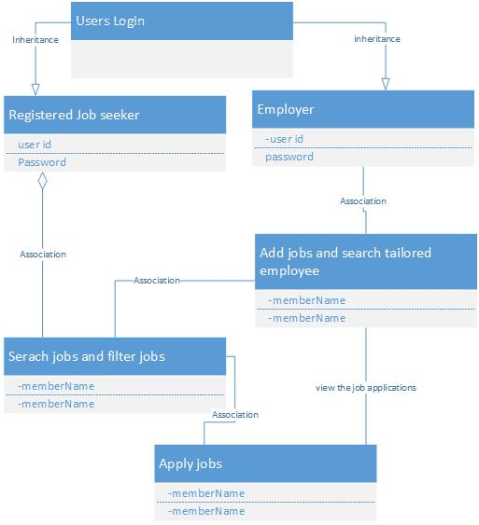

**Sequence Diagram:-**

The sequence of steps is as shown below.

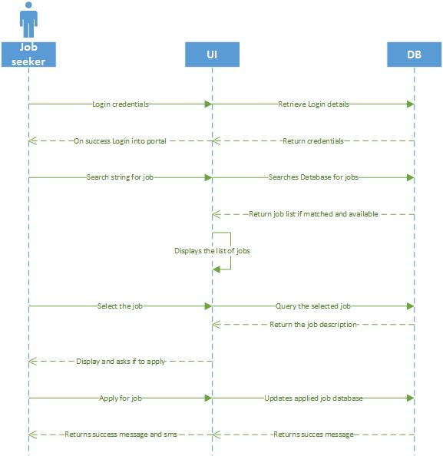

**2) Features Implemented**

**a. Web Services**

1. **Your own services**

<http://kc-sce-cs551.kc.umkc.edu/aspnet_client/Group6/T8-Restful/Service1.svc/insertInfo/siva/24/umkc/student>

Various operations and services like insertion, deletion and updating of the user data into the data base is been performed.

1. **Existing services/APIs**

We used various existing api’s from the Job search portals like search by using various parameters.

We implemented searching jobs based on country codes and names

**Job API**

[**http://api.careerbuilder.com/Search/jobsearch/jobsearchinfo.aspx**](http://api.careerbuilder.com/Search/jobsearch/jobsearchinfo.aspx)

**Places API –**

[**https://developers.google.com/places/documentation/?csw=1**](https://developers.google.com/places/documentation/?csw=1)

**b. Database**

Used SQL server DB for storing of all the registration details along with SQlite.

**c. Mobile User Interface**

We are using Android for our project development

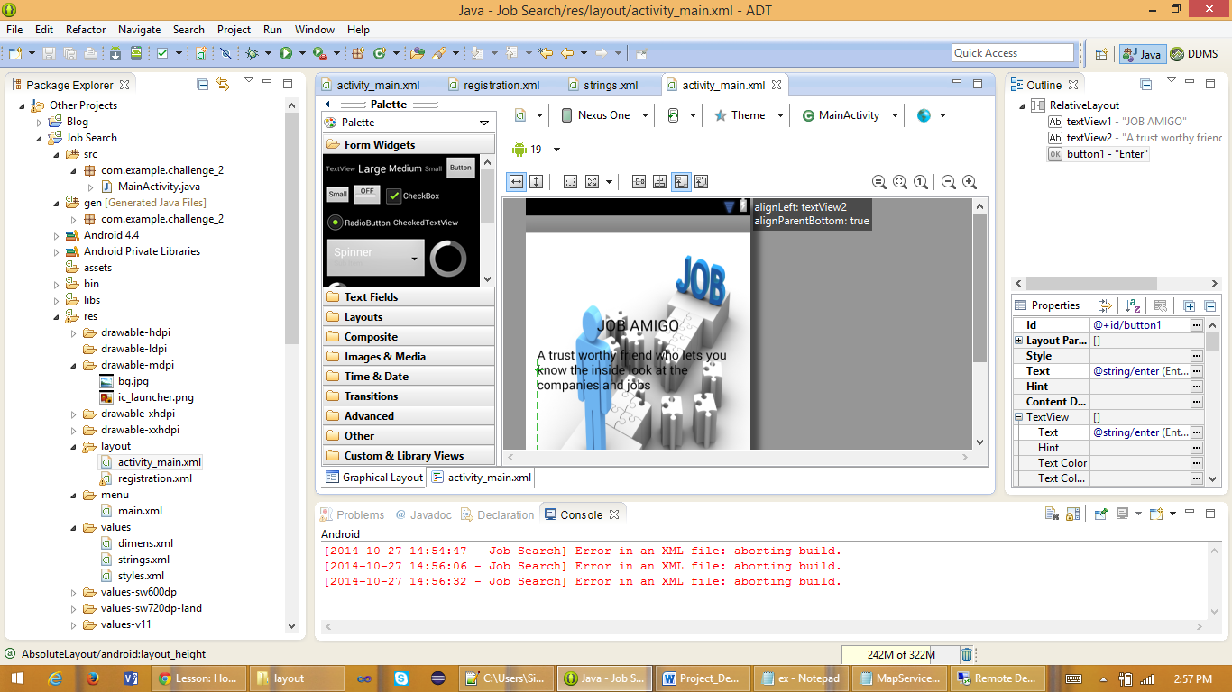

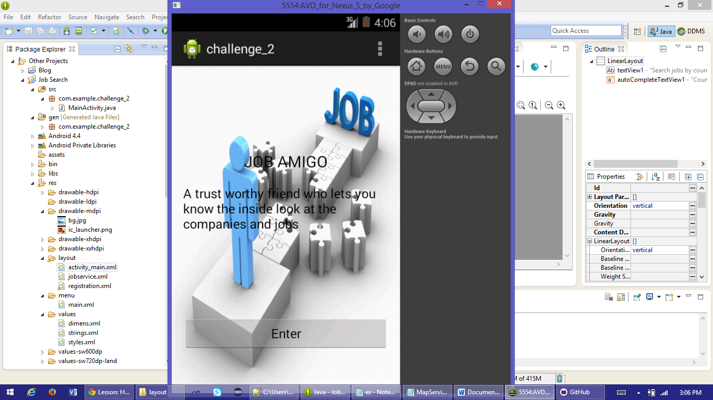

**3) Screenshots of the Features**

Following describes the features implemented

It retrieves all the job lists under the following category by using the API

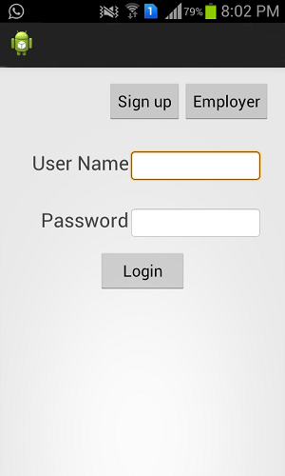

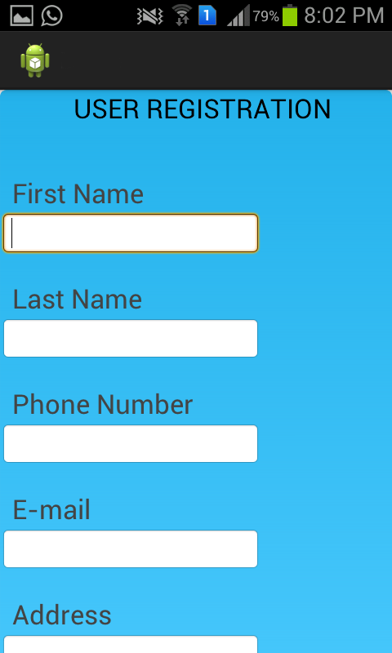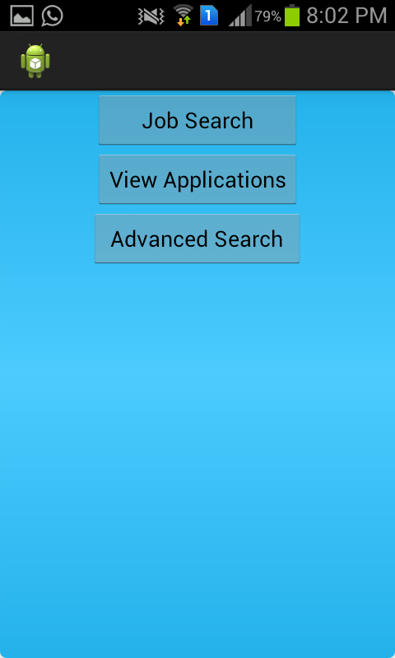

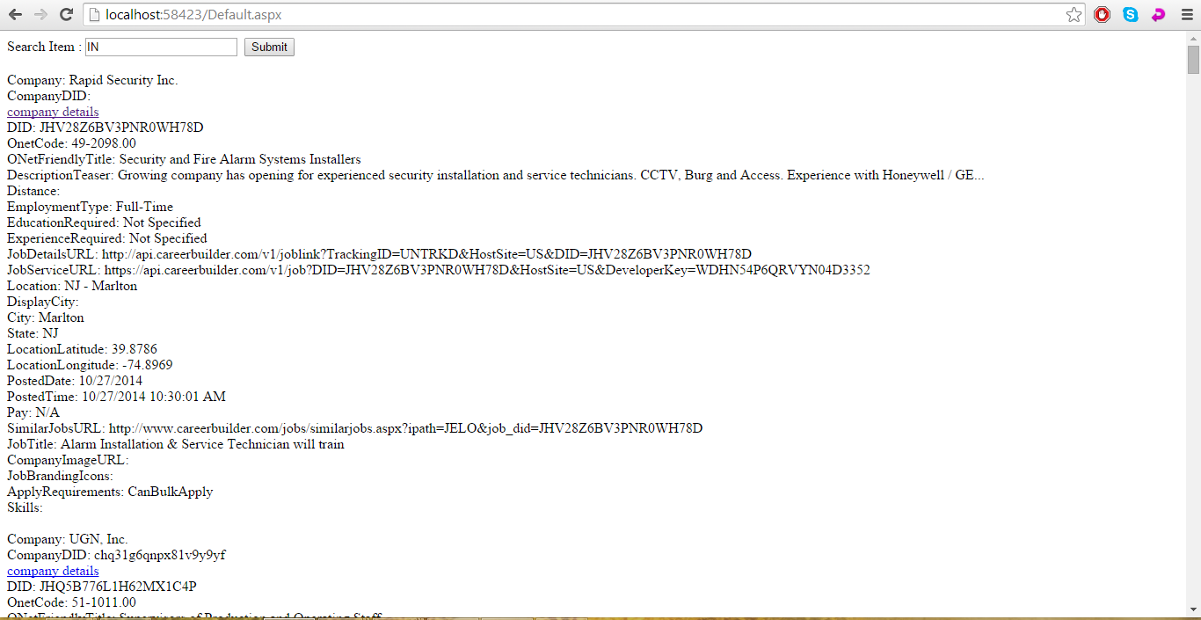

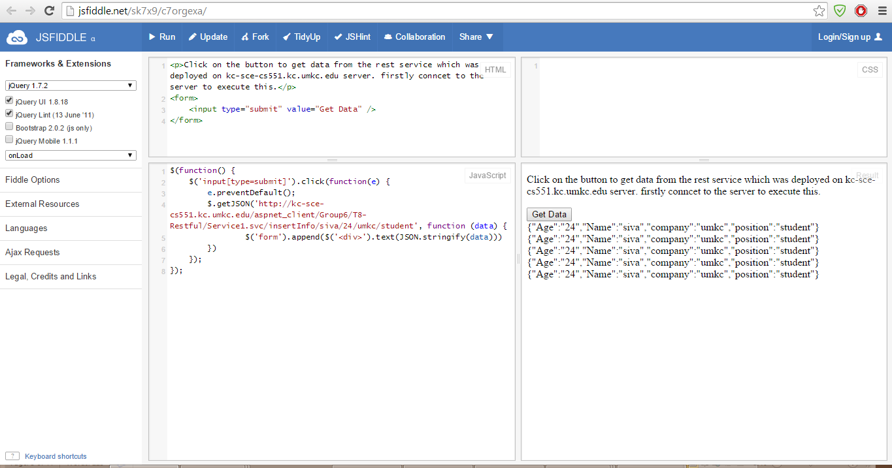

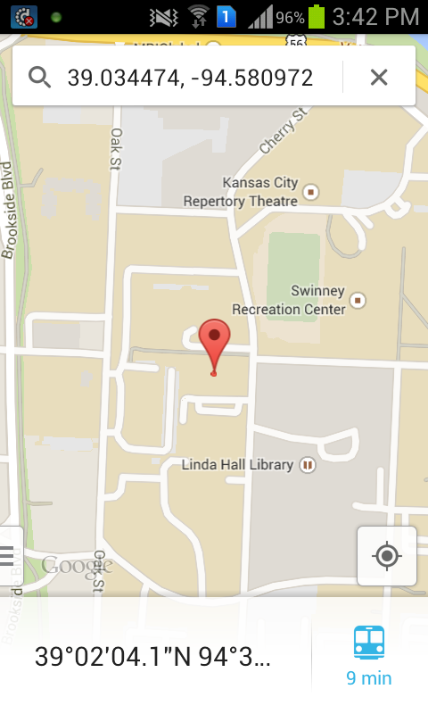

**4) Web Service and Web Site URLs**

<http://kc-sce-cs551.kc.umkc.edu/aspnet_client/Group6/T8-Restful/Service1.svc/insertInfo/siva/24/umkc/student>

<http://localhost:58423/Default.aspx>

<http://api.careerbuilder.com/Search/jobsearch/jobsearchinfo.aspx>

**5) Challenge#2 Github URL**

[**https://github.com/sk7x9/CS551-Challenge2**](https://github.com/sk7x9/CS551-Challenge2)

**Bibliography:-**

1. <http://realtimejobdata.splashthat.com/>

2. <http://bigapps2014.splashthat.com/>

3. <http://en.wikipedia.org/wiki/Web_application_development>

4. <https://www.google.com/>